|  |
| --- |
| Micah Schultz |
| GCHCC Database |
| Database Project |

|  |
| --- |
| Micah Schultz  CSIS 327-B01 LUO  Database Project  March 12th, 2017 |

**Problem Statement and Executive Summary**

God Cares Hospital for Catholic Converts or GCHCC is a charitable organization that operates many missionary hospitals around the globe. As GCHCC has grown, the organization has outgrown its original database system. The purpose of this project is to develop a database that will help GCHCC maintain its efforts and enhance their ability to manage and analyze critical data. The database will have the ability to manage hospitals facilities, department information, staff and patent records, and visits information.

The database that is to be developed will be required to solve the problems of managing the recording the operations of GCHCC facilities is such a many that will not limit future growth. To achieve this, special care has been given to develop a database structure that is efficient and easy to query. The database contained in this preliminary report is only designed to provide a basic framework, so that GCHCC can provide input on what elements to changed and expanded. The database is also constructed in such a manner that it can be easily expanded, as GCHCC is looking to expand its operation and desires easy expansion of management systems.

GCHCC is looking to expand its operation to several new facilities in a multiple countries. With this new database system, GCHCC will be able to effective spread the love of God though the medical services they provide. Medical care show the love of God by offer help to those that need it most. This database will enable GCHCC the continue its work with less resources going to management and more going to care.

**Database Table Design**

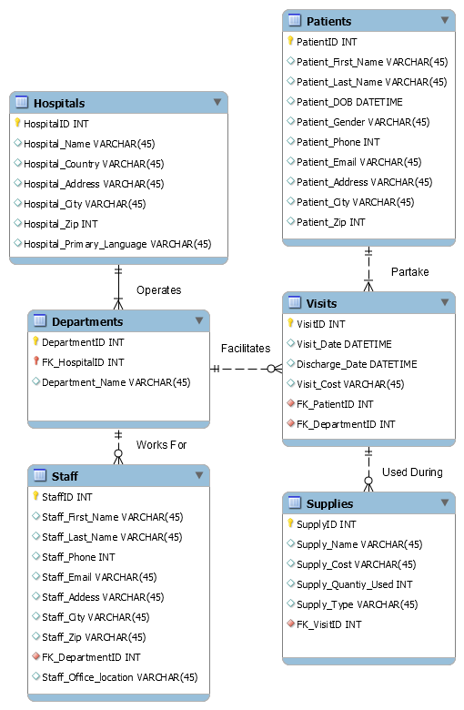

**Database Table Implementation**

CREATE TABLE Hospitals

(HospitalID INT CONSTRAINT HospitalID_PK PRIMARY KEY,

Hospital_Name VARCHAR(45) NOT NULL,

Hospital_Country VARCHAR(45) NOT NULL,

Hospital_Address VARCHAR(45),

Hospital_City VARCHAR(45),

Hospital_Zip INT,

Hospital_Primary_Language VARCHAR(45));

CREATE TABLE Departments

(DepartmentID INT UNIQUE NOT NULL,

FK_HospitalID INT NOT NULL,

Department_Name VARCHAR(45) NOT NULL,

CONSTRAINT Composit_PK PRIMARY KEY (DepartmentID,FK_HospitalID),

CONSTRAINT fk_Departments_Hospitals1 FOREIGN KEY

(FK_HospitalID) REFERENCES Hospitals (HospitalID));

CREATE TABLE Staff

(StaffID INT CONSTRAINT StaffID_PK PRIMARY KEY,

Staff_First_Name VARCHAR(45) NOT NULL,

Staff_Last_Name VARCHAR(45) NOT NULL,

Staff_Phone INT,

Staff_Email VARCHAR(45),

Staff_Addess VARCHAR(45),

Staff_City VARCHAR(45),

Staff_Zip VARCHAR(45),

FK_DepartmentID INT NOT NULL,

Staff_Office_location VARCHAR(45),

CONSTRAINT fk_Staff_Departments FOREIGN KEY

(FK_DepartmentID) REFERENCES Departments (DepartmentID));

CREATE TABLE Patients

(PatientID INT CONSTRAINT PatientID_PK PRIMARY KEY,

Patient_First_Name VARCHAR(45) NOT NULL,

Patient_Last_Name VARCHAR(45) NOT NULL,

Patient_DOB TIMESTAMP ,

Patient_Gender VARCHAR(45) NOT NULL,

Patient_Phone INT,

Patient_Email VARCHAR(45),

Patient_Address VARCHAR(45),

Patient_City VARCHAR(45),

Patient_Zip INT);

CREATE TABLE Visits

(VisitID INT CONSTRAINT VisitID_PK PRIMARY KEY,

Visit_Date TIMESTAMP NOT NULL,

Visit_Discharge_Date TIMESTAMP,

Visit_Cost VARCHAR(45),

FK_PatientID INT NOT NULL,

FK_DepartmentID INT NOT NULL,

CONSTRAINT fk_Visits_Patients1 FOREIGN KEY

(FK_PatientID) REFERENCES Patients (PatientID),

CONSTRAINT fk_Visits_Departments1 FOREIGN KEY

(FK_DepartmentID) REFERENCES Departments (DepartmentID));

CREATE TABLE Supplies

(SupplyID INT CONSTRAINT SupplyID_PK PRIMARY KEY,

Supply_Name VARCHAR(45) NOT NULL,

Supply_Cost VARCHAR(45),

Supply_Quantiy_Used INT,

Supply_Type VARCHAR(45),

FK_VisitID INT NOT NULL,

CONSTRAINT fk_Supplies_Visits FOREIGN KEY

(FK_VisitID) REFERENCES Visits (VisitID));

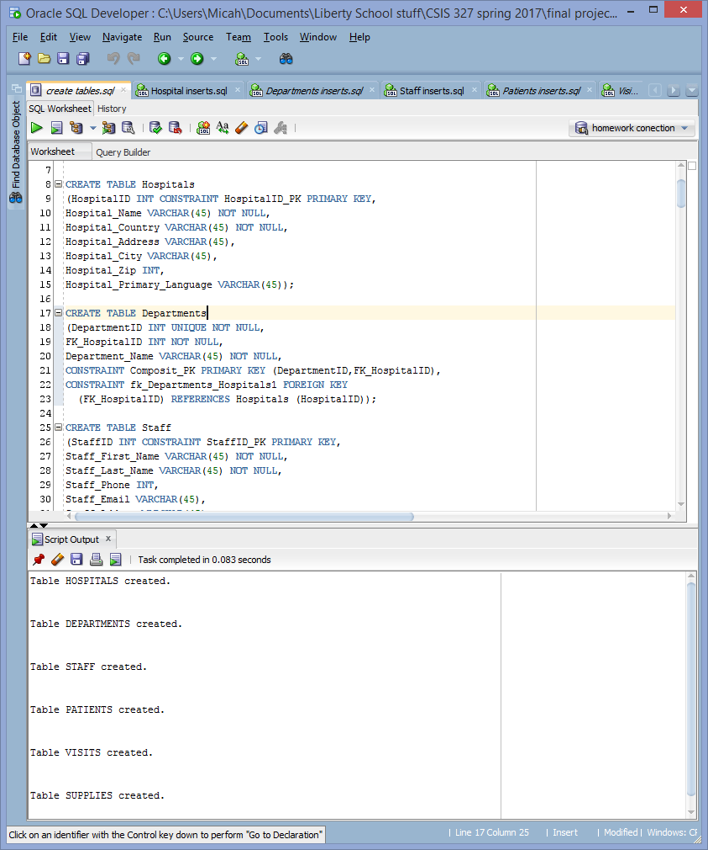

**Database Table Population**

INSERT INTO Hospitals (HospitalID, Hospital_Name, Hospital_Country, Hospital_Address, Hospital_City, Hospital_Zip, Hospital_Primary_Language)

VALUES (1000, 'Magic Medicine','USA', '123 Awesome St', 'Accident', 21520, 'English');

INSERT INTO Hospitals (HospitalID, Hospital_Name, Hospital_Country, Hospital_Address, Hospital_City, Hospital_Zip, Hospital_Primary_Language)

VALUES (1001, 'Happy Healthy','USA', '42 Second St', 'Dogtown', 35068, 'English');

INSERT INTO Hospitals (HospitalID, Hospital_Name, Hospital_Country, Hospital_Address, Hospital_City, Hospital_Zip, Hospital_Primary_Language)

VALUES (1002, 'Brave', 'USA', '564 Hospital St','Fearnot', 17968, 'English');

INSERT INTO Hospitals (HospitalID, Hospital_Name, Hospital_Country, Hospital_Address, Hospital_City, Hospital_Zip, Hospital_Primary_Language)

VALUES (1003, '1st OutReachMD','Mongolia', '1 First st', 'Moron', '', 'Mongolian');

INSERT INTO Hospitals (HospitalID, Hospital_Name, Hospital_Country, Hospital_Address, Hospital_City, Hospital_Zip, Hospital_Primary_Language)

VALUES (1004, 'Serious Care','Belgium', '66 Stern Dr', 'Silly', 7830, 'Dutch');

INSERT INTO Hospitals (HospitalID, Hospital_Name, Hospital_Country, Hospital_Address, Hospital_City, Hospital_Zip, Hospital_Primary_Language)

VALUES (1005, 'Supper Meidical','Turkey', '5649 Hero St', 'Batman', 72000, 'Turkish');

INSERT INTO Hospitals (HospitalID, Hospital_Name, Hospital_Country, Hospital_Address, Hospital_City, Hospital_Zip, Hospital_Primary_Language)

VALUES (1006, 'Mediocer Medicine','USA', '123 LetDown St', 'Accident', 21520, 'English');

INSERT INTO Hospitals (HospitalID, Hospital_Name, Hospital_Country, Hospital_Address, Hospital_City, Hospital_Zip, Hospital_Primary_Language)

VALUES (1007, 'Crucial Compashion','Uganda', '646 third St', 'Kampala', '', 'English');

INSERT INTO Hospitals (HospitalID, Hospital_Name, Hospital_Country, Hospital_Address, Hospital_City, Hospital_Zip, Hospital_Primary_Language)

VALUES (1008,'Wyoming County Community Health System','USA','400 N Main St','Warsaw', 14569, 'English');

INSERT INTO Hospitals (HospitalID, Hospital_Name, Hospital_Country, Hospital_Address, Hospital_City, Hospital_Zip, Hospital_Primary_Language)

VALUES (1009, '9th OutReachMD','Nepal', '1 First st', 'Kathmandu', '', 'Nepali');

INSERT INTO Hospitals (HospitalID, Hospital_Name, Hospital_Country, Hospital_Address, Hospital_City, Hospital_Zip, Hospital_Primary_Language)

VALUES (1010, 'No1 Hospital','kazakhstan ', '66 apple Dr', 'almaty', '', 'kazakh');

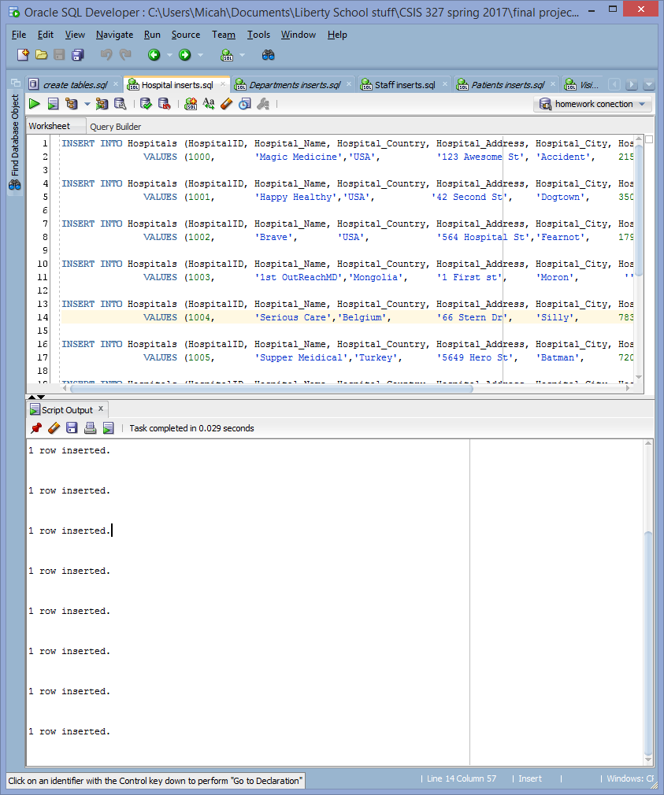

INSERT INTO Departments (DepartmentID, FK_HospitalID, Department_Name)

VALUES (1000, 1002, 'Professional training center');

INSERT INTO Departments (DepartmentID, FK_HospitalID, Department_Name)

VALUES (1001, 1002, 'Marketing ');

INSERT INTO Departments (DepartmentID, FK_HospitalID, Department_Name)

VALUES (1002, 1002, 'Pediatric center');

INSERT INTO Departments (DepartmentID, FK_HospitalID, Department_Name)

VALUES (1003, 1002, 'Professional training center');

INSERT INTO Departments (DepartmentID, FK_HospitalID, Department_Name)

VALUES (1004, 1003, 'Executive administration');

INSERT INTO Departments (DepartmentID, FK_HospitalID, Department_Name)

VALUES (1005, 1003, 'Accounting');

INSERT INTO Departments (DepartmentID, FK_HospitalID, Department_Name)

VALUES (1006, 1003, 'Critical care');

INSERT INTO Departments (DepartmentID, FK_HospitalID, Department_Name)

VALUES (1007, 1004, 'Information systems');

INSERT INTO Departments (DepartmentID, FK_HospitalID, Department_Name)

VALUES (1008, 1004, 'Critical care');

INSERT INTO Departments (DepartmentID, FK_HospitalID, Department_Name)

VALUES (1009, 1004, 'Pediatric center');

INSERT INTO Departments (DepartmentID, FK_HospitalID, Department_Name)

VALUES (1010, 1004, 'Professional training center');

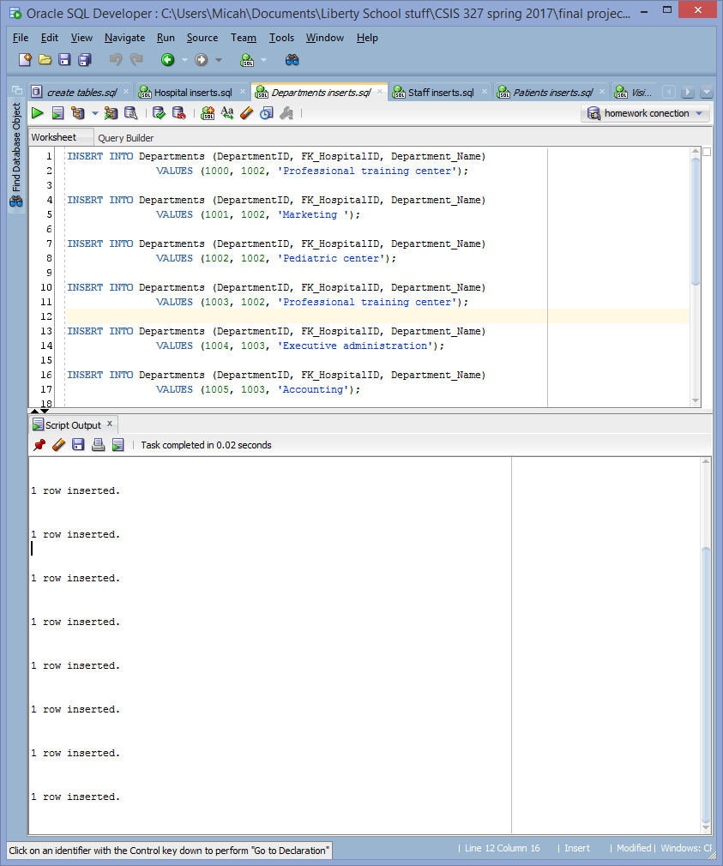

INSERT INTO Staff (StaffID, Staff_First_Name, Staff_Last_Name, Staff_Phone, Staff_Email, Staff_Addess, Staff_City, Staff_Zip, FK_DepartmentID, Staff_Office_location)

VALUES (1000, 'Mayte', 'Treasure', 1234567890, 'Terson59@rhyta.com','8782 N. Wintergreen Circle','Vicksburg',39180,1000,'East Wing');

INSERT INTO Staff (StaffID, Staff_First_Name, Staff_Last_Name, Staff_Phone, Staff_Email, Staff_Addess, Staff_City, Staff_Zip, FK_DepartmentID, Staff_Office_location)

VALUES (1001, 'Kleio', 'Ishani', 1234567890, 'Eforst56@superrito.com','8 East Cactus Drive','Reynoldsburg',32137,1001,'Basement');

INSERT INTO Staff (StaffID, Staff_First_Name, Staff_Last_Name, Staff_Phone, Staff_Email, Staff_Addess, Staff_City, Staff_Zip, FK_DepartmentID, Staff_Office_location)

VALUES (1002, 'Divya', 'Tiwlip', 1234567890, 'Ablemplaid48@cuvox.de','115 E. Rock Creek Circle','Palm Coast',32137,1002,'Top Floor');

INSERT INTO Staff (StaffID, Staff_First_Name, Staff_Last_Name, Staff_Phone, Staff_Email, Staff_Addess, Staff_City, Staff_Zip, FK_DepartmentID, Staff_Office_location)

VALUES (1003, 'Roland', 'Sebastian', 1234567890, 'Abse1957@einrot.com','679 Pacific Dr.','Reading',01867,1003,'');

INSERT INTO Staff (StaffID, Staff_First_Name, Staff_Last_Name, Staff_Phone, Staff_Email, Staff_Addess, Staff_City, Staff_Zip, FK_DepartmentID, Staff_Office_location)

VALUES (1004, 'Indira', 'Rajeev', 1234567890, 'Thut1953@superrito.com','43 West Shady Court','Snohomish',98290,1004,'Main Building');

INSERT INTO Staff (StaffID, Staff_First_Name, Staff_Last_Name, Staff_Phone, Staff_Email, Staff_Addess, Staff_City, Staff_Zip, FK_DepartmentID, Staff_Office_location)

VALUES (1005, 'Ionas', 'Filipina', 1234567890, 'Derry1942@rhyta.com','721 Oak Lane','Poughkeepsie',12601,1005,'Main Building');

INSERT INTO Staff (StaffID, Staff_First_Name, Staff_Last_Name, Staff_Phone, Staff_Email, Staff_Addess, Staff_City, Staff_Zip, FK_DepartmentID, Staff_Office_location)

VALUES (1006, 'Nirmal', 'Doncho', 1234567890, 'Gorry1980@fleckens.hu','24 Paris Hill Road','South Portland',04106,1006,'Basement');

INSERT INTO Staff (StaffID, Staff_First_Name, Staff_Last_Name, Staff_Phone, Staff_Email, Staff_Addess, Staff_City, Staff_Zip, FK_DepartmentID, Staff_Office_location)

VALUES (1007, 'Uranus', 'Eusebius', 1234567890, 'Capt1929@rhyta.com','533 Bank Lane','Williamsburg',23185,1007,'East Wing');

INSERT INTO Staff (StaffID, Staff_First_Name, Staff_Last_Name, Staff_Phone, Staff_Email, Staff_Addess, Staff_City, Staff_Zip, FK_DepartmentID, Staff_Office_location)

VALUES (1008, 'Zulfaqar', 'Uduak', 1234567890, 'Olde1931@einrot.com','9192 Sussex Dr.','Camas',98607,1008,'Secound Building');

INSERT INTO Staff (StaffID, Staff_First_Name, Staff_Last_Name, Staff_Phone, Staff_Email, Staff_Addess, Staff_City, Staff_Zip, FK_DepartmentID, Staff_Office_location)

VALUES (1009, 'Patroclus', 'Hakan', 1234567890, 'Amen1978@superrito.com','718 Littleton Road','Fort Washington',20744,1009,'Main Building');

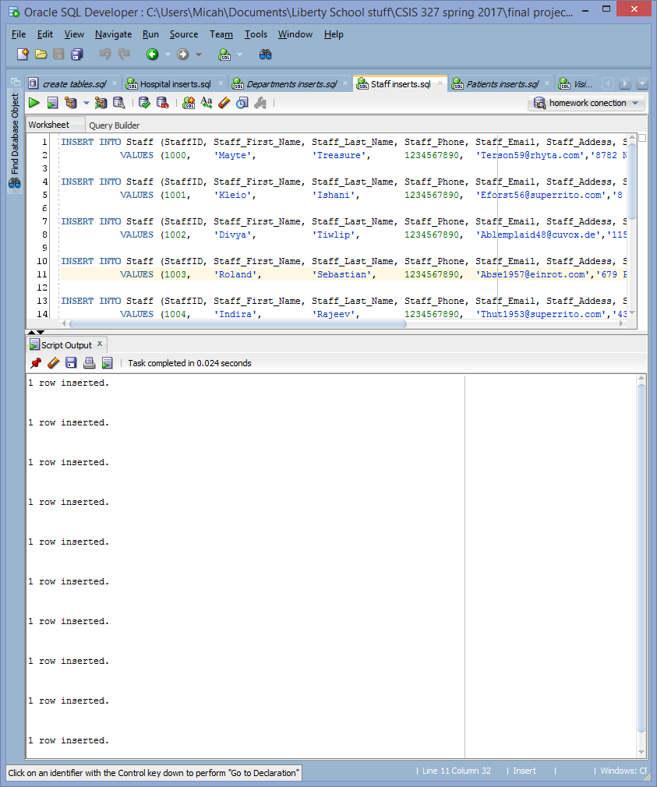

INSERT INTO Patients (PatientID, Patient_First_Name, Patient_Last_Name, Patient_DOB, Patient_Gender, Patient_Phone, Patient_Email, Patient_Address, Patient_City, Patient_Zip)

VALUES (1000, 'Vidya', 'Aleksey','27-Oct-2037 06:28:20','Female',1234567890,'Spond1983@cuvox.de',' 386 West Drive','Kernersville',27284);

INSERT INTO Patients (PatientID, Patient_First_Name, Patient_Last_Name, Patient_DOB, Patient_Gender, Patient_Phone, Patient_Email, Patient_Address, Patient_City, Patient_Zip)

VALUES (1001, 'Widald', 'Louise','19-Feb-1972 07:25:24','Female',1234567890,'Havis1969@dayrep.com','36 North Smoky Hollow Ave.','Olympia',98512);

INSERT INTO Patients (PatientID, Patient_First_Name, Patient_Last_Name, Patient_DOB, Patient_Gender, Patient_Phone, Patient_Email, Patient_Address, Patient_City, Patient_Zip)

VALUES (1002, 'Khasan', 'Taliesin','31-Dec-2010 02:51:26','Female',1234567890,'Eass1945@superrito.com','45 Marsh Rd.','Merrimack',03054);

INSERT INTO Patients (PatientID, Patient_First_Name, Patient_Last_Name, Patient_DOB, Patient_Gender, Patient_Phone, Patient_Email, Patient_Address, Patient_City, Patient_Zip)

VALUES (1003, 'Prateek', 'Hyacinth','17-Nov-2002 11:12:27','Female',1234567890,'Shmidecir@armyspy.com','427 University Ave.','Cincinnati',45211);

INSERT INTO Patients (PatientID, Patient_First_Name, Patient_Last_Name, Patient_DOB, Patient_Gender, Patient_Phone, Patient_Email, Patient_Address, Patient_City, Patient_Zip)

VALUES (1004, 'Aoife', 'Iliyana','26-Nov-2037 07:12:22','Female',1234567890,'Thars1990@rhyta.com','8246 Beaver Ridge Ave.','Hamilton',45011);

INSERT INTO Patients (PatientID, Patient_First_Name, Patient_Last_Name, Patient_DOB, Patient_Gender, Patient_Phone, Patient_Email, Patient_Address, Patient_City, Patient_Zip)

VALUES (1005, 'Dominik', 'Jeronim','23-Jan-1972 10:16:59','Female',1234567890,'Buddard1929@gustr.com','8782 N. Wintergreen Circle','Vicksburg',39180);

INSERT INTO Patients (PatientID, Patient_First_Name, Patient_Last_Name, Patient_DOB, Patient_Gender, Patient_Phone, Patient_Email, Patient_Address, Patient_City, Patient_Zip)

VALUES (1006, 'Mordad', 'Dip','09-Jun-1984 10:51:59','Female',1234567890,'Comee1977@cuvox.de','45 Briarwood Ave.','Providence',02904);

INSERT INTO Patients (PatientID, Patient_First_Name, Patient_Last_Name, Patient_DOB, Patient_Gender, Patient_Phone, Patient_Email, Patient_Address, Patient_City, Patient_Zip)

VALUES (1007, 'Fleur', ' Ireneus','23-Dec-2028 01:10:25','Female',1234567890,'Witiet41@teleworm.us','19 Jones Drive','Rosemount',55068);

INSERT INTO Patients (PatientID, Patient_First_Name, Patient_Last_Name, Patient_DOB, Patient_Gender, Patient_Phone, Patient_Email, Patient_Address, Patient_City, Patient_Zip)

VALUES (1008, 'Duha', 'Keitha','24-Jun-1994 02:58:56','Female',1234567890,'Harl1984@jourrapide.com','823 Union St.','Woburn',01801);

INSERT INTO Patients (PatientID, Patient_First_Name, Patient_Last_Name, Patient_DOB, Patient_Gender, Patient_Phone, Patient_Email, Patient_Address, Patient_City, Patient_Zip)

VALUES (1009, 'Ana', 'Alard','08-Dec-1975 12:52:54','Female',1234567890,'Fals1934@dayrep.com','6 Market Lane','Irvington',07111);

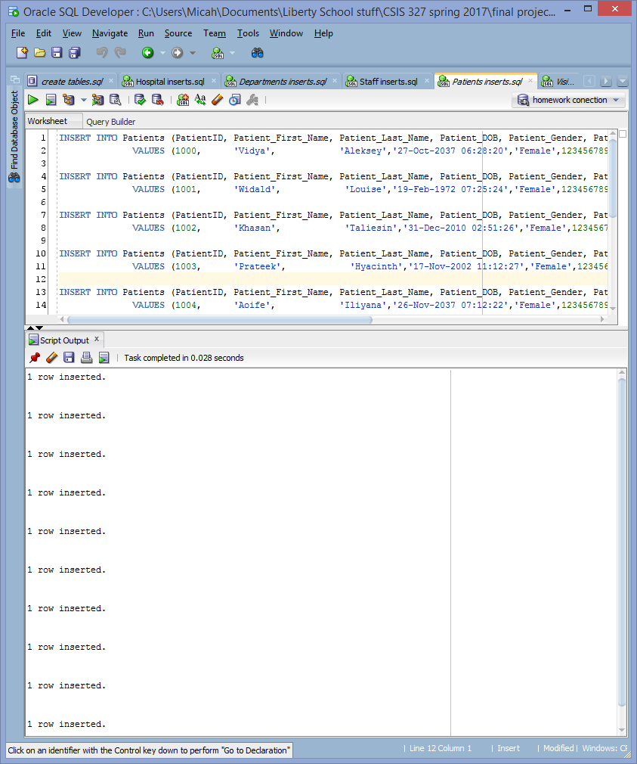

INSERT INTO Visits (VisitID, Visit_Date, Visit_Discharge_Date, Visit_Cost, FK_PatientID, FK_DepartmentID)

VALUES (1000, '18-Jul-1988 10:47:07','04-Dec-2006 07:37:18',4643,1000, 1008 );

INSERT INTO Visits (VisitID, Visit_Date, Visit_Discharge_Date, Visit_Cost, FK_PatientID, FK_DepartmentID)

VALUES (1001, '14-Jan-1987 06:31:43', '30-Jun-1998 05:41:45',1012,1001, 1008 );

INSERT INTO Visits (VisitID, Visit_Date, Visit_Discharge_Date, Visit_Cost, FK_PatientID, FK_DepartmentID)

VALUES (1002, '14-Jan-2001 01:02:11','', '', 1002, 1008 );

INSERT INTO Visits (VisitID, Visit_Date, Visit_Discharge_Date, Visit_Cost, FK_PatientID, FK_DepartmentID)

VALUES (1003, '18-Jun-1998 03:56:38','', '', 1003, 1009 );

INSERT INTO Visits (VisitID, Visit_Date, Visit_Discharge_Date, Visit_Cost, FK_PatientID, FK_DepartmentID)

VALUES (1004, '25-Jan-1985 10:04:19','02-Dec-1998 12:06:44',619881,1004, 1009 );

INSERT INTO Visits (VisitID, Visit_Date, Visit_Discharge_Date, Visit_Cost, FK_PatientID, FK_DepartmentID)

VALUES (1005, '25-Dec-2002 11:34:33','', '', 1005, 1006 );

INSERT INTO Visits (VisitID, Visit_Date, Visit_Discharge_Date, Visit_Cost, FK_PatientID, FK_DepartmentID)

VALUES (1006, '17-Oct-1996 12:51:26','18-Oct-1996 12:51:26',10000,1006, 1006 );

INSERT INTO Visits (VisitID, Visit_Date, Visit_Discharge_Date, Visit_Cost, FK_PatientID, FK_DepartmentID)

VALUES (1007, '30-May-2013 06:16:54','30-Jun-2013 11:16:54',61891,1007, 1006 );

INSERT INTO Visits (VisitID, Visit_Date, Visit_Discharge_Date, Visit_Cost, FK_PatientID, FK_DepartmentID)

VALUES (1008, '07-Dec-1999 10:30:27','14-Dec-1999 08:30:27',99,1008, 1002 );

INSERT INTO Visits (VisitID, Visit_Date, Visit_Discharge_Date, Visit_Cost, FK_PatientID, FK_DepartmentID)

VALUES (1009, '17-Jun-2003 11:45:06','17-Jun-2003 11:45:06','',1009, 1002 );

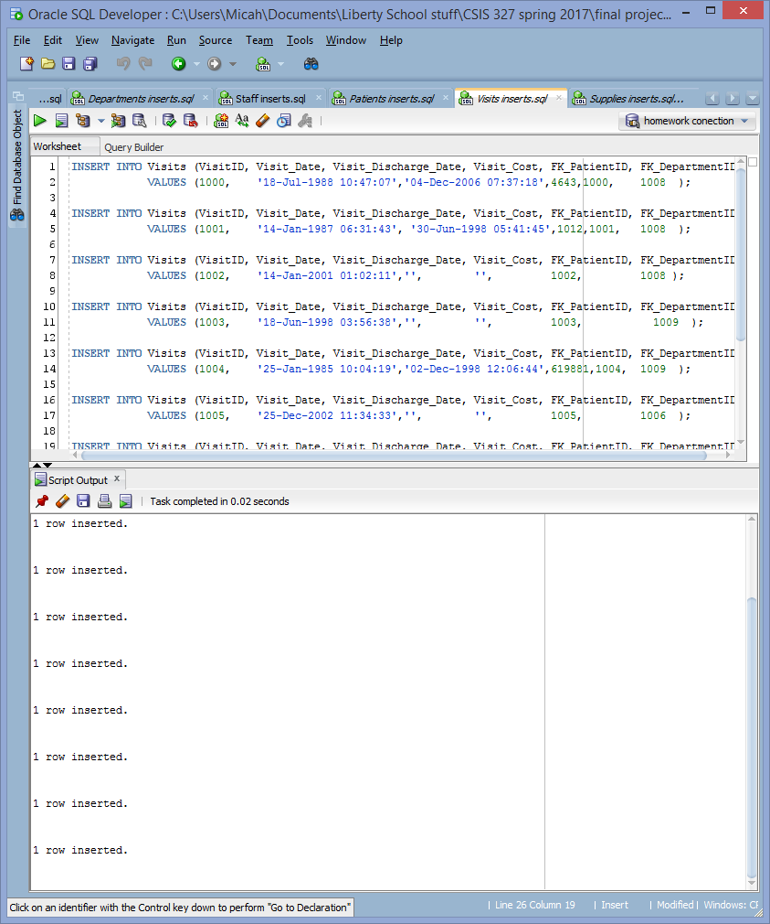

INSERT INTO Supplies (SupplyID, Supply_Name, Supply_Cost, Supply_Quantiy_Used, Supply_Type, FK_VisitID)

VALUES (1000, 'Bandages', 2, 14, 'Wound Care',1000);

INSERT INTO Supplies (SupplyID, Supply_Name, Supply_Cost, Supply_Quantiy_Used, Supply_Type, FK_VisitID)

VALUES (1001, 'Gauze', 13, 100, 'Wound Care',1001);

INSERT INTO Supplies (SupplyID, Supply_Name, Supply_Cost, Supply_Quantiy_Used, Supply_Type, FK_VisitID)

VALUES (1002, 'Ointments', 7, 3, 'Wound Care',1002);

INSERT INTO Supplies (SupplyID, Supply_Name, Supply_Cost, Supply_Quantiy_Used, Supply_Type, FK_VisitID)

VALUES (1003, 'Oxygen Masks',120, 1, 'Respiratory',1003);

INSERT INTO Supplies (SupplyID, Supply_Name, Supply_Cost, Supply_Quantiy_Used, Supply_Type, FK_VisitID)

VALUES (1004, 'Oxygen Tank',185, 3, 'Respiratory',1004);

INSERT INTO Supplies (SupplyID, Supply_Name, Supply_Cost, Supply_Quantiy_Used, Supply_Type, FK_VisitID)

VALUES (1005, 'Scalpel', 27, 5, 'Surgical', 1005);

INSERT INTO Supplies (SupplyID, Supply_Name, Supply_Cost, Supply_Quantiy_Used, Supply_Type, FK_VisitID)

VALUES (1006, 'Mask', 1, 50, 'Surgical', 1006);

INSERT INTO Supplies (SupplyID, Supply_Name, Supply_Cost, Supply_Quantiy_Used, Supply_Type, FK_VisitID)

VALUES (1007, 'Morphine', 1000, 2, 'Emergency and Trauma',1007);

INSERT INTO Supplies (SupplyID, Supply_Name, Supply_Cost, Supply_Quantiy_Used, Supply_Type, FK_VisitID)

VALUES (1008, 'Splint', 57, 1, 'Emergency and Trauma',1008);

INSERT INTO Supplies (SupplyID, Supply_Name, Supply_Cost, Supply_Quantiy_Used, Supply_Type, FK_VisitID)

VALUES (1009, 'Cast', 300, 2, 'Emergency and Trauma',1009);

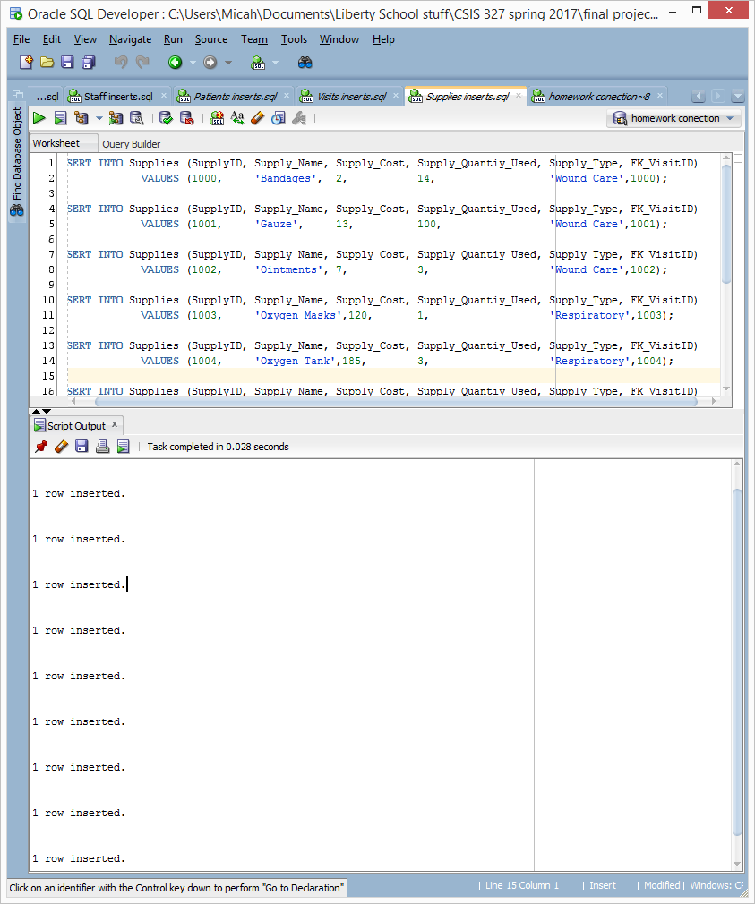

**SQL Reports**

Lists active hospitals and the number of departments they operate.

SELECT DISTINCT h.HOSPITAL_NAME, count(d.DEPARTMENTID) "number of active departments"

FROM HOSPITALS h join Departments d

on h.HOSPITALID = d.FK_HOSPITALID

group by h.HOSPITAL_NAME;

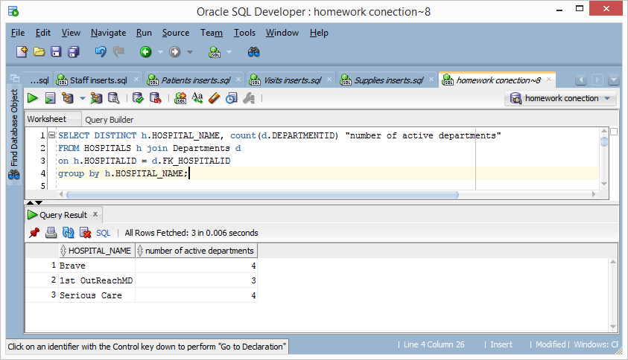

Lists patients and the supplies used in their visits.

SELECT p.PATIENT_FIRST_NAME, p.PATIENT_LAST_NAME,

s.SUPPLY_NAME, s.SUPPLY_TYPE,

s.SUPPLY_COST * s.SUPPLY_QUANTIY_USED "cost of itmes used"

FROM PATIENTS p join visits v

on p.PATIENTID = v.FK_PATIENTID

join supplies s

on v.VISITID = s.FK_VISITID ;

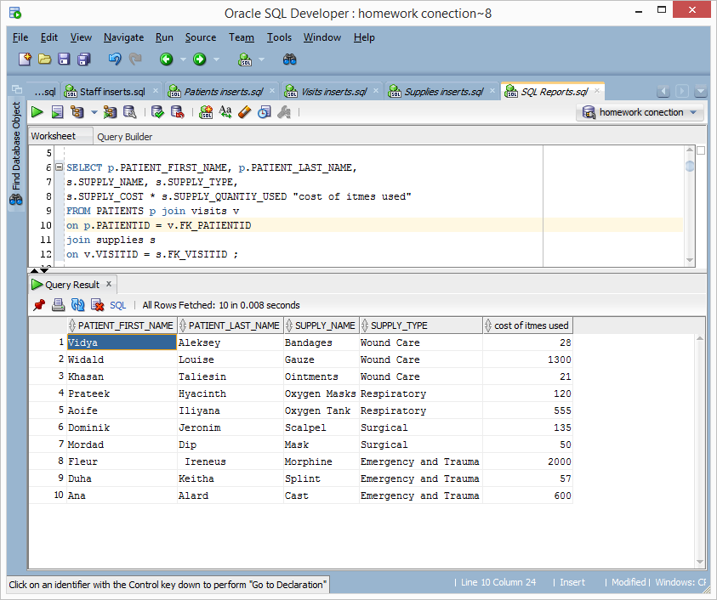

Lists patients whose visit cost more than the average visit.

SELECT p.PATIENT_FIRST_NAME, p.PATIENT_LAST_NAME, v.VISIT_COST

FROM PATIENTS p join visits v on p.PATIENTID = v.FK_PATIENTID

where v.VISIT_COST > (SELECT AVG(VISIT_COST) FROM visits);

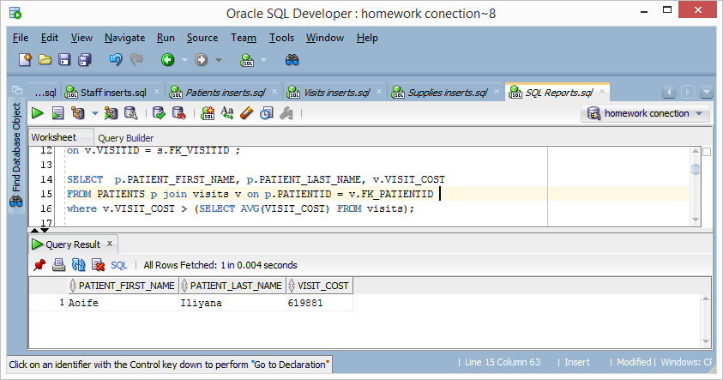

Lists hospitals with no active departments i.e. shutdown or not yet open

SELECT HOSPITALID, HOSPITAL_NAME, HOSPITAL_CITY, HOSPITAL_COUNTRY, HOSPITAL_PRIMARY_LANGUAGE

FROM HOSPITALS

where HOSPITALID in(

SELECT HOSPITALID FROM HOSPITALS minus

(SELECT DISTINCT FK_HOSPITALID FROM Departments));

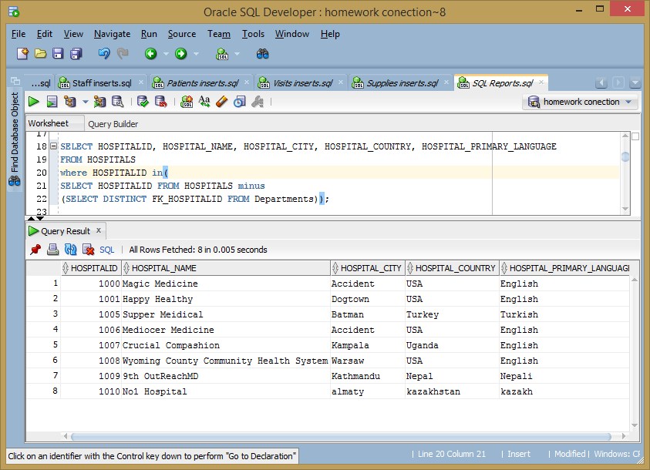

Lists departments who have had visits that cost more than 0 dollars.

SELECT * FROM Departments

where DEPARTMENTID in

(select DEPARTMENTID

from Departments d join VISITS v

on d.DEPARTMENTID = v.FK_DEPARTMENTID

where v.VISIT_COST > 0);

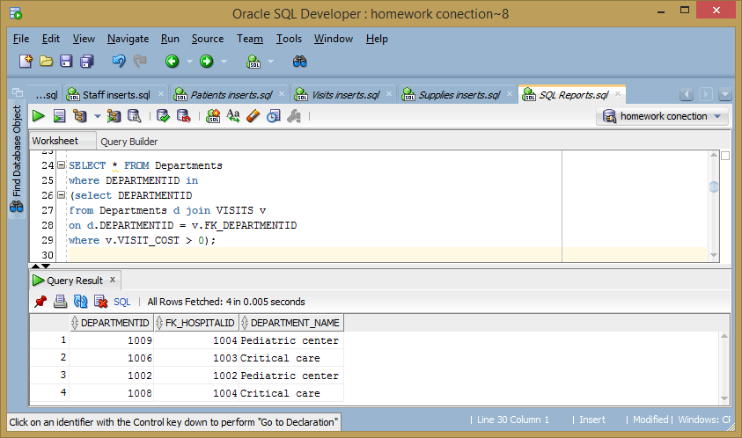

Lists staff who are in departments the conduct visits

SELECT STAFFID, STAFF_FIRST_NAME, STAFF_LAST_NAME, FK_DEPARTMENTID, STAFF_EMAIL FROM Staff

where STAFFID in

(SELECT DISTINCT STAFFID

FROM Staff s join Departments d

on s.FK_DEPARTMENTID = d.DEPARTMENTID

join visits v

on d.DEPARTMENTID = v.FK_DEPARTMENTID);

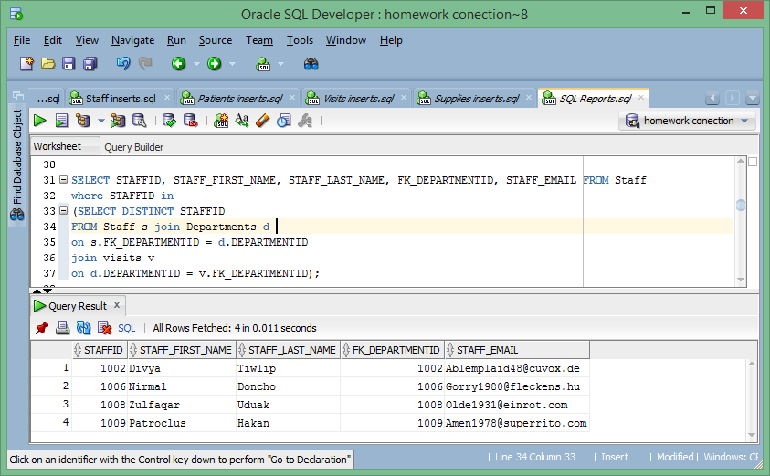

Lists visit length in days and related information for visits that are less than the average visit cost.

SELECT VISITID, VISIT_DISCHARGE_DATE - VISIT_DATE "visist length",

FK_PATIENTID, FK_DEPARTMENTID, VISIT_COST

FROM Visits

where VISIT_DISCHARGE_DATE is not null and VISITID IN

(SELECT VISITID FROM Visits minus

(SELECT VISITID FROM Visits

where VISIT_COST > (SELECT AVG(VISIT_COST)

FROM visits)));

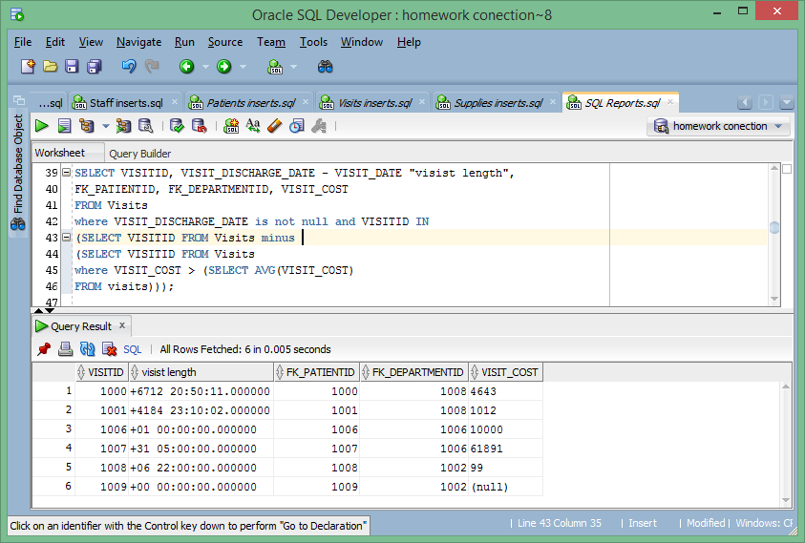

**Schema Objects**

CREATE INDEX HOSPITALS_index

ON HOSPITALS (HospitalID, Hospital_Name);

CREATE INDEX Departments_index

ON Departments (DepartmentID, Department_Name);

CREATE INDEX Staff_index

ON Staff (StaffID, Staff_First_Name, Staff_Last_Name);

CREATE INDEX PATIENTS_index

ON PATIENTS (PatientID, Patient_First_Name, Patient_Last_Name);

CREATE INDEX Visits_index

ON Visits (VisitID, Visit_Date);

CREATE INDEX SUPPLIES_index

ON SUPPLIES (SupplyID, Supply_Name);

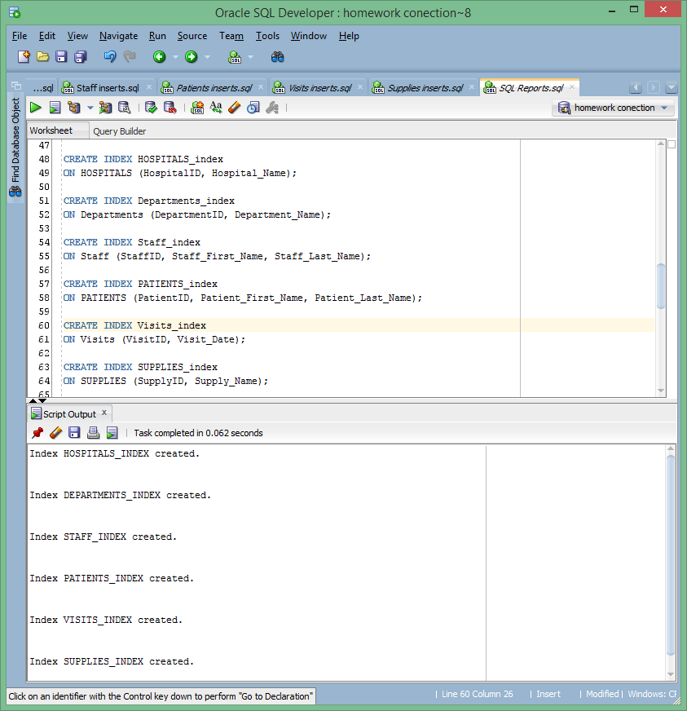

View of patents and visits info for Serious Care hospital.

create view Patents_of_Serious_Care as

SELECT p.PATIENTID, v.VISIT_DATE, v.VISIT_COST,

p.PATIENT_FIRST_NAME, p.PATIENT_LAST_NAME,

p.PATIENT_DOB, p.PATIENT_PHONE, p.PATIENT_EMAIL,

p.PATIENT_ADDRESS, p.PATIENT_CITY, p.PATIENT_ZIP

FROM PATIENTS p join visits v

on p.PATIENTID = v.FK_PATIENTID

join Departments d

on d.DEPARTMENTID = v.FK_DEPARTMENTID

join HOSPITALS h

on d.FK_HOSPITALID = h.HOSPITALID

where HOSPITALID = 1004;

View of staff and department info for Brave hospital

create view Staff_of_Brave as

SELECT s.STAFFID, d.DEPARTMENTID, d.DEPARTMENT_NAME,

s.STAFF_FIRST_NAME, s.STAFF_LAST_NAME, s.STAFF_PHONE, s.STAFF_EMAIL,

s.STAFF_OFFICE_LOCATION, s.STAFF_ADDESS, s.STAFF_CITY, s.STAFF_ZIP

FROM Staff s

join Departments d

on s.FK_DEPARTMENTID = d.DEPARTMENTID

join HOSPITALS h

on d.FK_HOSPITALID = h.HOSPITALID

where HOSPITALID = 1002;

CREATE SEQUENCE PATIENTID_SEQUENCE

START WITH 1010

INCREMENT BY 1

MAXVALUE 9000;